Lutheran Hour Ministries Gospel Outreach in Malaysia Bible Radio Project
$ 7,500
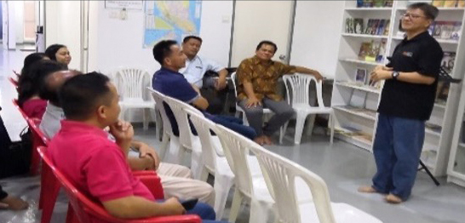
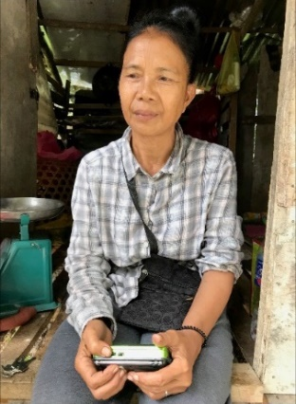
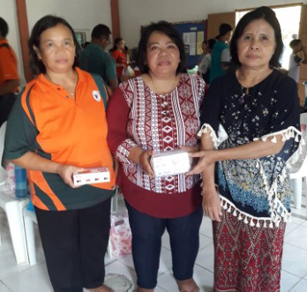

Lutheran Hour Ministries has an urgent need to provide Gospel resources and services. New opportunities during these challenging times will enable us to continue to spread the Gospel and help those in need.

LHM has developed the audio Bible Radio Project as an outreach ministry to enable the people of Malaysia to hear the Word of God in their own languages, strengthening them and encouraging them in the faith.

We appreciate the opportunity to share this mission-focused project with you, the women of the LWML Washington-Alaska District.

2022-2024 Biennium – LWML Washington-Alaska District

